**EXPT NO: 7 A python program to implement Decisiontree DATE: 04.10.2024**

# AIM:

To write a python program to implement a Decisiontree.

# PROCEDURE:

Implementing the decision tree using the Irisdataset involve the following steps:

**Step1:Import Necessary Libraries**

First,import the libraries that are essential for data manipulation,visualization,and model building.

import numpy as np importpandasaspd

from sklearn import datasets

fromsklearn.model_selectionimporttrain_test_split from sklearn.tree import DecisionTreeClassifier

from sklearn import metrics

import matplotlib.pyplot as plt

from sklearn.tree import plot_tree

**Step2:LoadtheIrisDataset**

TheIrisdatasetcanbeloadedanddisplaythefirstfewrowsofthedataset.

# Load the Iris dataset

iris = datasets.load_iris()

X = iris.data # Features

y = iris.target #Target variable

**Step3:Split the dataset into training and testingsets**

# Split the dataset into training and testing sets

X_train,X_test,y_train,y_test=train_test_split(X,y,test_size=0.2, random_state=42)

**Step4:Create a decision tree classifier**

# Create a Decision Tree classifier

clf= DecisionTreeClassifier(random_state=42)

**Step5:Train the model:**

# Train the model

clf.fit(X_train, y_train)

# OUTPUT:

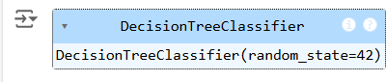

**Step6:Makethepredictionsandevaluatethemodel**

# Make predictions

y_pred = clf.predict(X_test)

# Evaluate the model

accuracy = metrics.accuracy_score(y_test, y_pred) confusion=metrics.confusion_matrix(y_test,y_pred)

classification_report = metrics.classification_report(y_test, y_pred)

print(f"Accuracy:{accuracy:.2f}") print("Confusion Matrix:")

print(confusion)

print("ClassificationReport:") print(classification_report)

# OUTPUT:

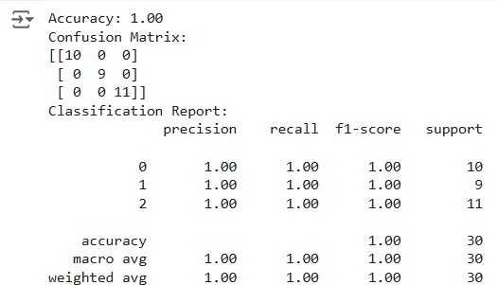

**Step7:Visualizethedecisiontree**

#VisualizetheDecisionTree plt.figure(figsize=(12,8))

plot_tree(clf,filled=True,feature_names=iris.feature_names, class_names=iris.target_names)

plt.title("DecisionTreeVisualization") plt.show()

# OUTPUT:

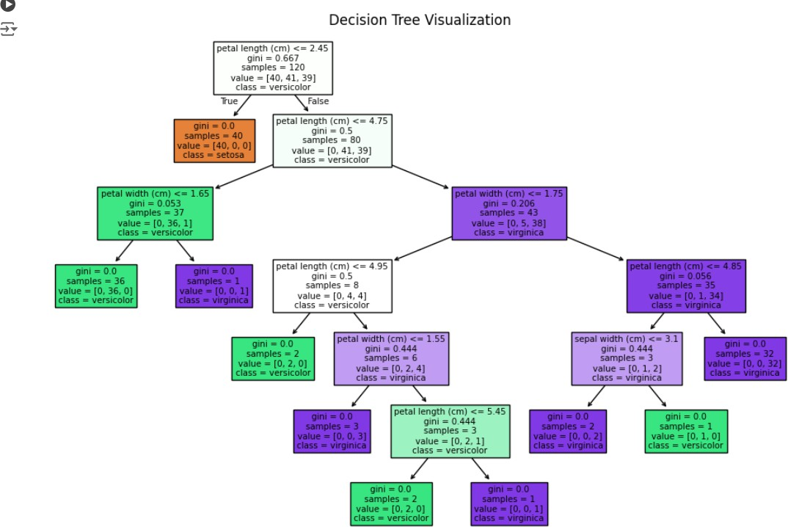

**RESULT:**

**This process helps us to implement the decision tree using a python program.**